**Miss Wooldridge’s Shopping List**

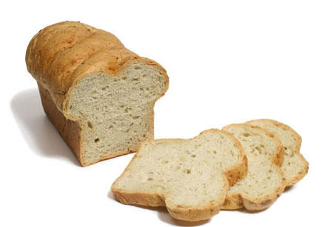

1 loaf of white bread

500g butter

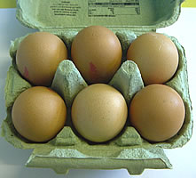

6 eggs

6 pints of milk

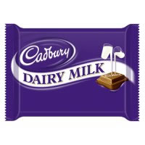

1 Large bar of Cadbury’s Dairy Milk

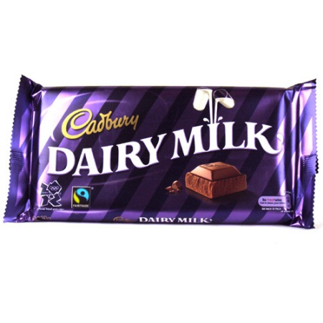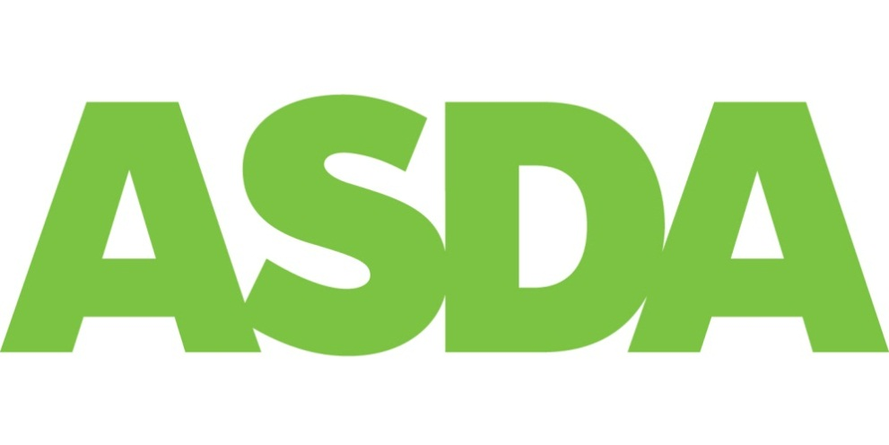

£1 when bought with Kingsmill bread

£1

30% off!

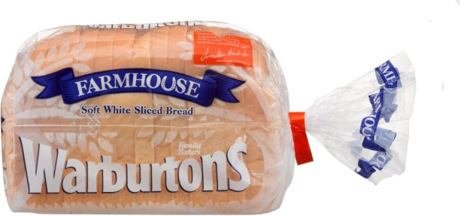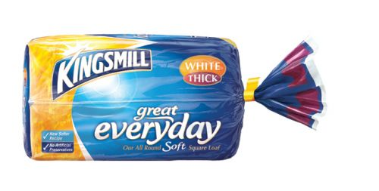

£1.30

40% off!

£1.75

50% extra free!

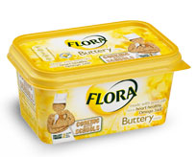

£1.75

10% off!

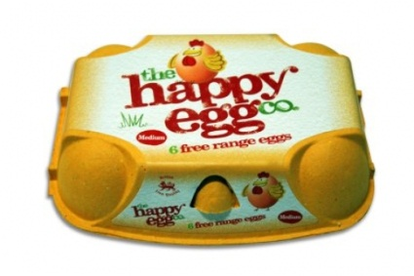

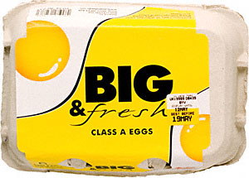

50p when bought with warbutons bread

£2

46% off!



£2.25

35% off!

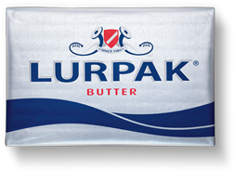

6 pints for £1.50

37% off!

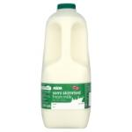

£1.35

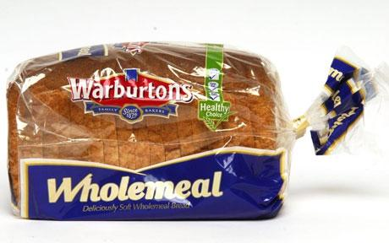

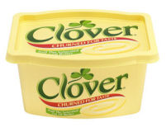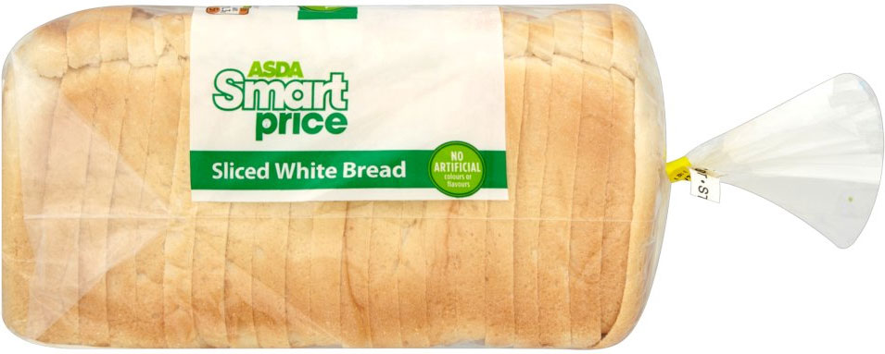

£2

28% off!

£2

10% off!

£0.70



£1

4 pints + 50% extra free!

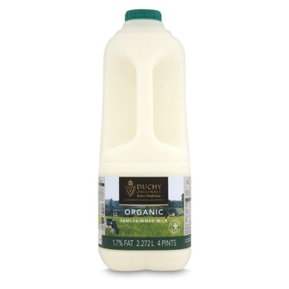

£1.20

50% extra free!

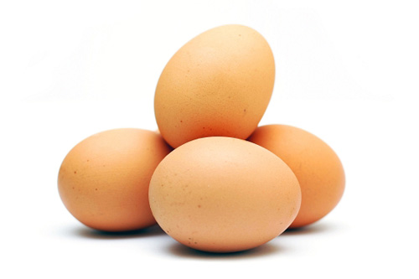

50 p each

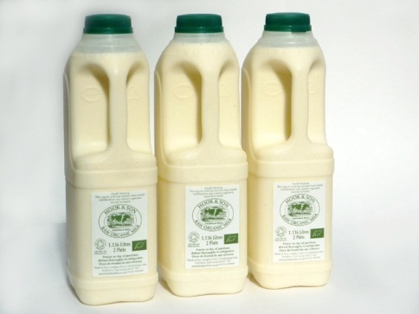

Please use this page for your working out!!

Check List:

|  |  |  |
| --- | --- | --- |
| Item | Brand | Cost |
| Bread |  |  |
| Milk |  |  |
| Eggs |  |  |
| Butter |  |  |
| Chocolate |  |  |

Penalties

Total Spent = £ .